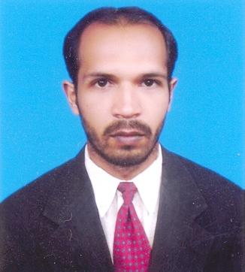
CONTACT INFORMATION

Nadeem Shahzad Mobile: +92(0342)1734633
House #P46 Street # 5 Email:Nadeem189rb@gmail.com
Maqsood abad- Chak Jhumran
Faisalabad.

CAREER OBJECTIVE

A position in a results-oriented organization that seeks an ambitious and career conscious person, where acquired skills and education will be utilized towards continued growth and advancement. Also to achieve excellence in the career and provide services with utmost commitment and dedication in a professional and career- oriented organization.

PERSONAL INFORMATION

Nationality: Pakistan
Birth date: 12 Apr, 1982
Gender: Male
Marital Status: Married

PROFESSIONAL EXPERIENCE

Asst. Network Administrator
Bismillah Fabrics Pvt. Ltd.
Ph: 92-41-4363322
Network Administrator
Sweetytextiles Pvt Ltd.
Jaranwala Road Khurianwala.
+92(41)545514.
EDUCATION

Master, Computer Science(Continue)
Virtual University Of Pakistan

Bachelors, Computer Science
Allama Iqbal Open University Islamabad.

I.C.S (Inter in Computer Science)
Govt.Degree College faisalabad

S.S.C.
Govt.Higher Secondary School Chak Jhumran

TARGET JOB

Job Location: Anywhere
Job Category: Information Technology
Employment Status: Full time
SKILLS

WINDOWS SERVER: Microsoft Windows 2003, 2000 Server
Client OS: Microsoft Windows 98, 2000, XP.
File & Print Server: Microsoft Windows 2003.
Cabling: Gigabit Ethernet STP.
Server Machines: Dell, Compaq
Switches: D-Link, 3COM,
Mdaemon 9.5(version)
ISA Server: 2000,2005
Internet Services: ISDN, DSL.
Microsoft Office: MS-Word, Excel, Outlook
Backup & Recovery: Third party & Built-in softwares.
Antivirus Server: Symantec Corporate

Reference

It will be available on your demand.

